**Practical No: 1**

a. Study different libraries used for NLP in python.

b. Install NLTK Package.

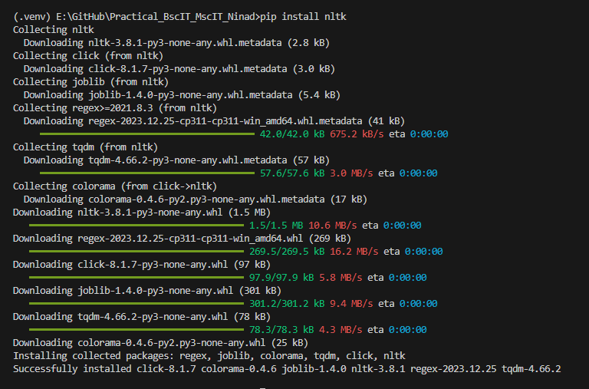

**AIM: Convert the given text into speech.**

**Description:**

**Code:**

# Import the required module for text to speech conversion

#!pip install gtts

from gtts import gTTS

# This module is imported so that we can play the converted audio

import os

# The text that you want to convert to audio

mytext = "Hello Everyone!My name is Ninad"

# Language in which you want to convert

language = "en"

# Passing the text and language to the engine, here we have marked slow=False. Which tells the module that the converted audio should have a high speed

myobj = gTTS(text=mytext, lang=language, slow=False)

# Saving the converted audio in a mp3 file named welcome

myobj.save("welcomeNK.mp3")

# Playing the converted file

os.system("mpg321 welcomeNK.mp3")

**Output:**

**AIM: Convert the speech to text**

**Description:**

**Code:**

#Aim: Convert audio file Speech to Text.

#Note: required to store the input file "NLP_test.wav" in the current folder before running the program.

!pip install SpeechRecognition pydub

import speech_recognition as sr

filename = "/content/NLP_test.wav"

# initialize the recognizer

r = sr.Recognizer()

# open the file

with sr.AudioFile(filename) as source:

# listen for the data (load audio to memory)

audio_data = r.record(source)

# recognize (convert from speech to text)

text = r.recognize_google(audio_data)

print(text)

**Practical No: 2**

a.

**Practical No: 3**

a.

**Practical No: 4**

a.